

Student Id : NP03A190051

Student Name : Rishab Sharma

Section : L5CG7

Lecturer : Jnaneshwor Bohara

Module Leader : Hiran Patel

Submitted on : 18th September, 2021

[Workshop Report-1]

The following code prints out the value of an int variable and a string (char *) :

#include <stdio.h>

void main(int argc, char *argv[])

{

int age = 10;

char *name = "Hiran";

printf("Hello %s, you are %d years old.", name, age);

}

1. Now modify the program so that it uses the command line arguments to supply name and age. i.e. it uses the argc and argv arguments/parameters.

When you run it, it should produce the following:

./myprog Jnaneshwar 100

Hello Jnaneshwar, you are 100 years old.

= > #include <stdio.h>

#include <unistd.h>

void main (int argc, char *argv[])

{

printf("Hello %s, you are %s years old", argv[1], argv[2]);

}

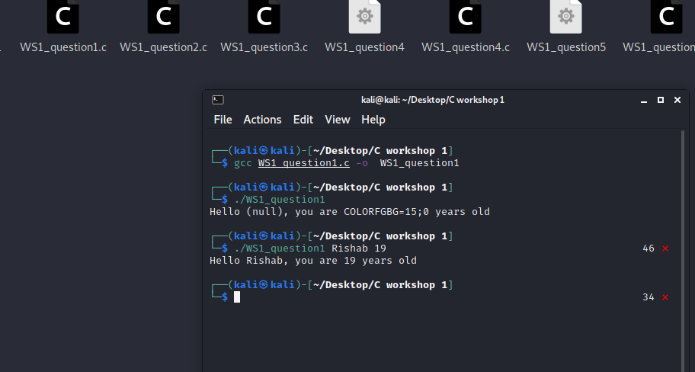

1. Now modify the program again so that it uses the scanf() function to get input from the user for the name and age.

The following code count the integer variable n from 0 to 9 and prints out “Odd” if n is even and just the value of n if it is even:

= > #include <stdio.h>

void main()

{

char name [20];

int age;

scanf("%s", name);

scanf("%d", &age);

printf("Hello %s, you are %d years old.", name, age);

}

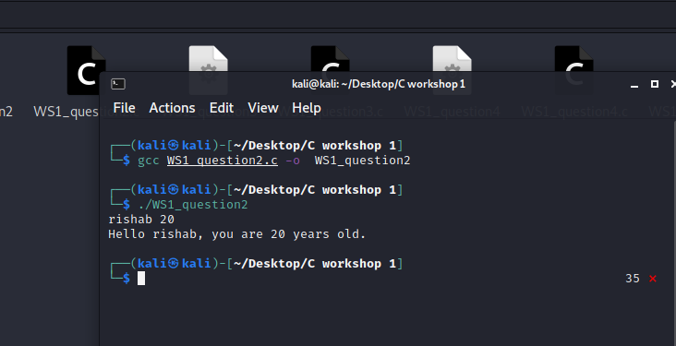

1. Now modify the program so that it counts the variable n from 1 to 100 and, if n is a multiple of 2 ( eg. 2, 4, 6, etc), it would print out the word “Bish”, and if n is a multiple of 3 (eg. 3, 6, 9. 12 etc), it would print out the word “Bash”, and if n is a multiple of 5 (eg. 5, 10, 15 etc), it would print out the word “Bosh”.

However, if n is a multiple of 2 and 3 (eg. 6), it would print out the words “BishBash”, and if n is a multiple of 2 and 5 (eg. 10), it would print out the words “BishBosh”, and if n is a multiple of 3 and 5 (eg. 15), it would print out the words “BashBosh”. Finally, if n is a multiple of 2, 3 and 5 (eg. 30), it would print out the words “BishBashBosh”.

= > #include <stdio.h>

void main (int argc, char *argv[]) {

for (int n=1; n<=100; n++) {

if(n % 2 == 0 && n % 3 == 0 && n % 5 == 0) {

printf("BishBashBosh\n");

}

else if(n % 3 == 0 && n % 5 == 0) {

printf("BashBosh\n");

}

else if(n % 2 == 0 && n % 5 == 0) {

printf("BishBosh\n");

}

else if(n % 2 == 0 && n % 3 == 0) {

printf("BishBash\n");

}

else if(n % 2 == 0) {

printf("Bish\n");

}

else if(n % 3 == 0) {

printf("Bash\n");

}

else if(n % 5 == 0) {

printf("Bosh\n");

}

else if(n % 3 == 0) {

printf("BishBash\n");

}

else {

printf("%d\n", n);

}

}

}

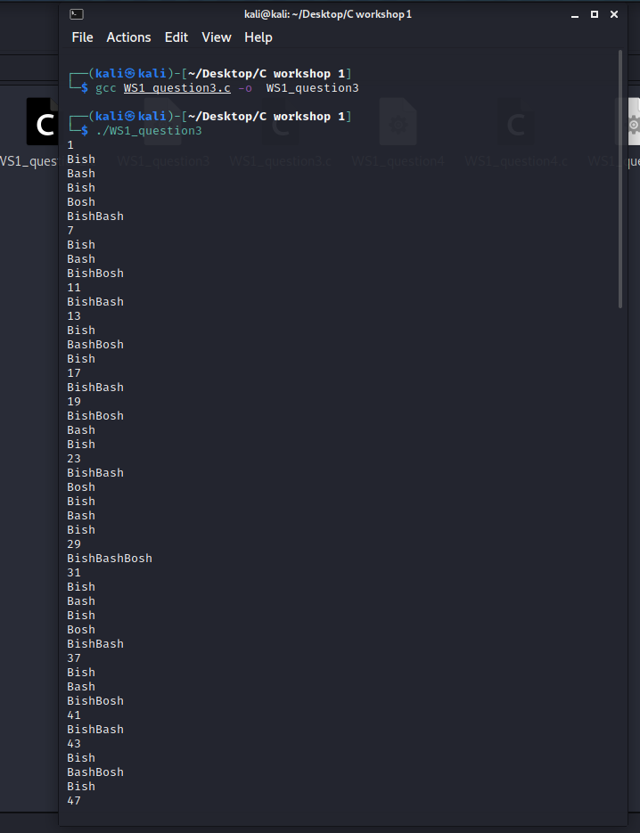

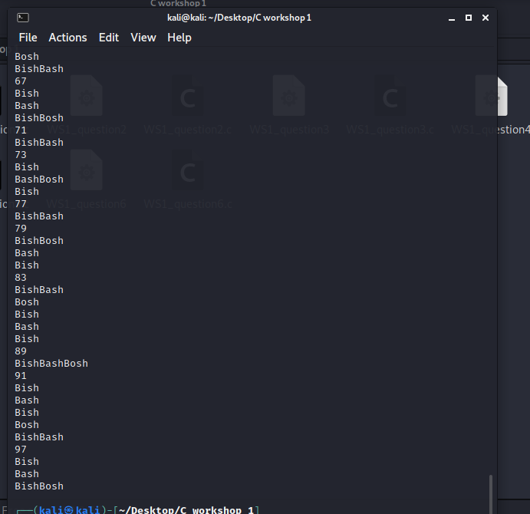

1. Now write a function called swap() that would swap the values of the variables a and b, when you call the swap() with the variables a and b as parameters. Please note, this exercise requires pointers.

The following program fills an int array of size 10 and fills it with random numbers and prints them out:

= > #include<stdio.h>

void swap(int *a, int *b)

{

int temp;

temp = *a;

*a = *b;

*b = temp;

}

void main()

{

int a,b;

printf("Enter the value of a and b respectively:");

scanf("%d%d",&a,&b);

swap(&a,&b);

printf("After swaping the value:\n");

printf("A:%d\tB:%d",a,b);

}

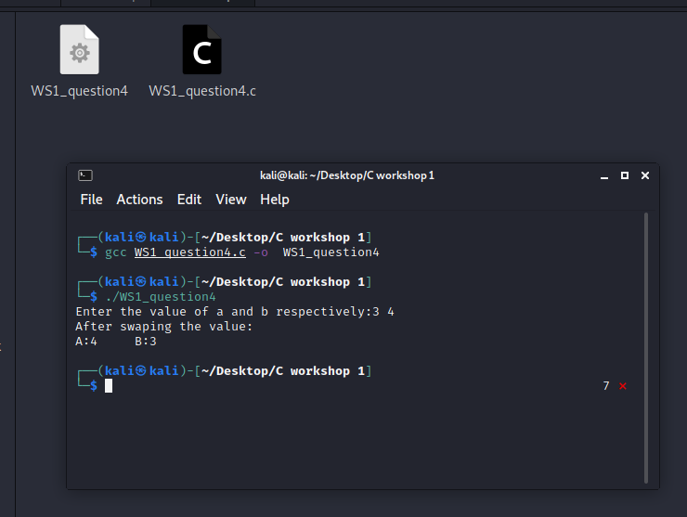

1. Now modify it to will ask the user for a number between 1 and 50, and then use the C function malloc() to allocate an int array of that size, fill it with random numbers and print out the value of each element of that array.

The following code creates 2 threads in a program and counts to 10 in each thread :

= > #include<stdio.h>

#include<stdlib.h>

void main(){

int n,i; // n is total number of items

int *p; //pointer variable

printf("Enter a number between 1 to 50:");

scanf("%d",&n);

p = (int*)malloc(n * sizeof(int));

for(i=0;i<n;i++){

*(p+i) = rand();

}

for ( i = 0; i < n; i++)

{

printf("%d\n",*(p+i));

}

}

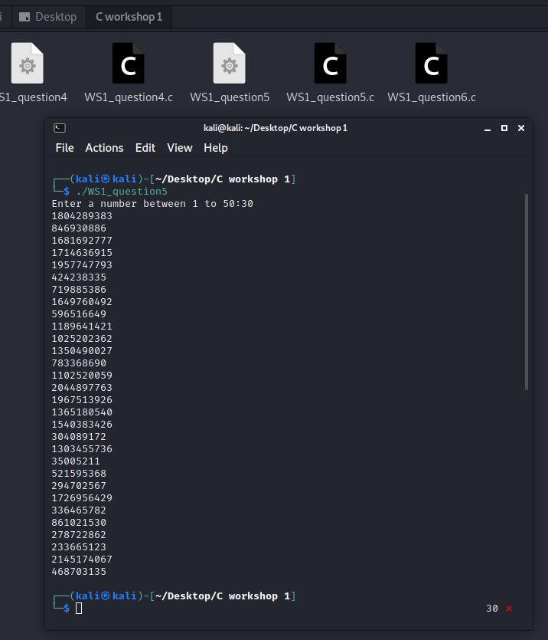

1. Modify the program to accept a command line argument to specific the number of threads, and then create that many threads dynamically to run.

= > #include <stdlib.h>

#include <stdio.h>

int main() {

int i;

for(i=0;i<5;i++)

{

printf("%d,", i);

}

printf("\n");

while(i<10)

{

printf("%d,", i);

i++;

}

do {

printf("%d,", i);

i++;

}

while(i<15);

printf("\n");

if(i>13){

printf("custard\n");

} else

{

printf("gravy\n");

}

return EXIT_SUCCESS;

}

